IAT 381 PO1: PROCESS

### Kevin Chua

### 301119503

Brief

A local, two-person company that sells breads will need a website. They need to be able to sell product online, and want to ensure that their website speaks to their small and local nature.

## Client's Need

* A way to post company updates and events
* Company History (Emphasis their small and local nature)
* Product listing with detailed product view. As this is a two person bread shop that features only bread made in store, the selection of bread product will not be extensive and a search bar will not be implemented.
* A way for users to provide feedback on products
* A way to purchase items online
* An aesthetically attractive site that fits their upscale store
* A way to collect customer data

## User’s Needs and expectations

* An easy to understand layout
* Being able look at the products quickly
* Able to find company contact information and location easily
* Online ordering for personal and catering needs
* Secure transaction
* Product listing
* A way to identify the best products
* Way to estimate wait time (Depends on the size of the order)
* A way to store account Information

## Additional Notes

* The “Our Process” webpage will be used to show the users were the raw materials are sourced from and the manufacturing process. This will be used to emphasis the local nature of the store.
* Individual products should have detail information and customer reviews
* Larger orders might better harder to complete on time so they need to be ordered in advance.
* User can create accounts to store credit card information, have bread subscriptions (Weekly orders of bread the user as set to buy) and be able to review items they have purchase
* Potential to feature local bread artisans to showcase their bread.

# Week 1: Sketches

## Step 1: Site Structure

I realized the company was supposed to have a two person run local company feel so I wanted to strip down the site structure to the bare minimum. Furthermore, I did not include the search bar as it didn’t make sense for the Bread shop to carry too many types of bread because there they are a small shop.

## Step 2: Sketches

### Desktop Sketches

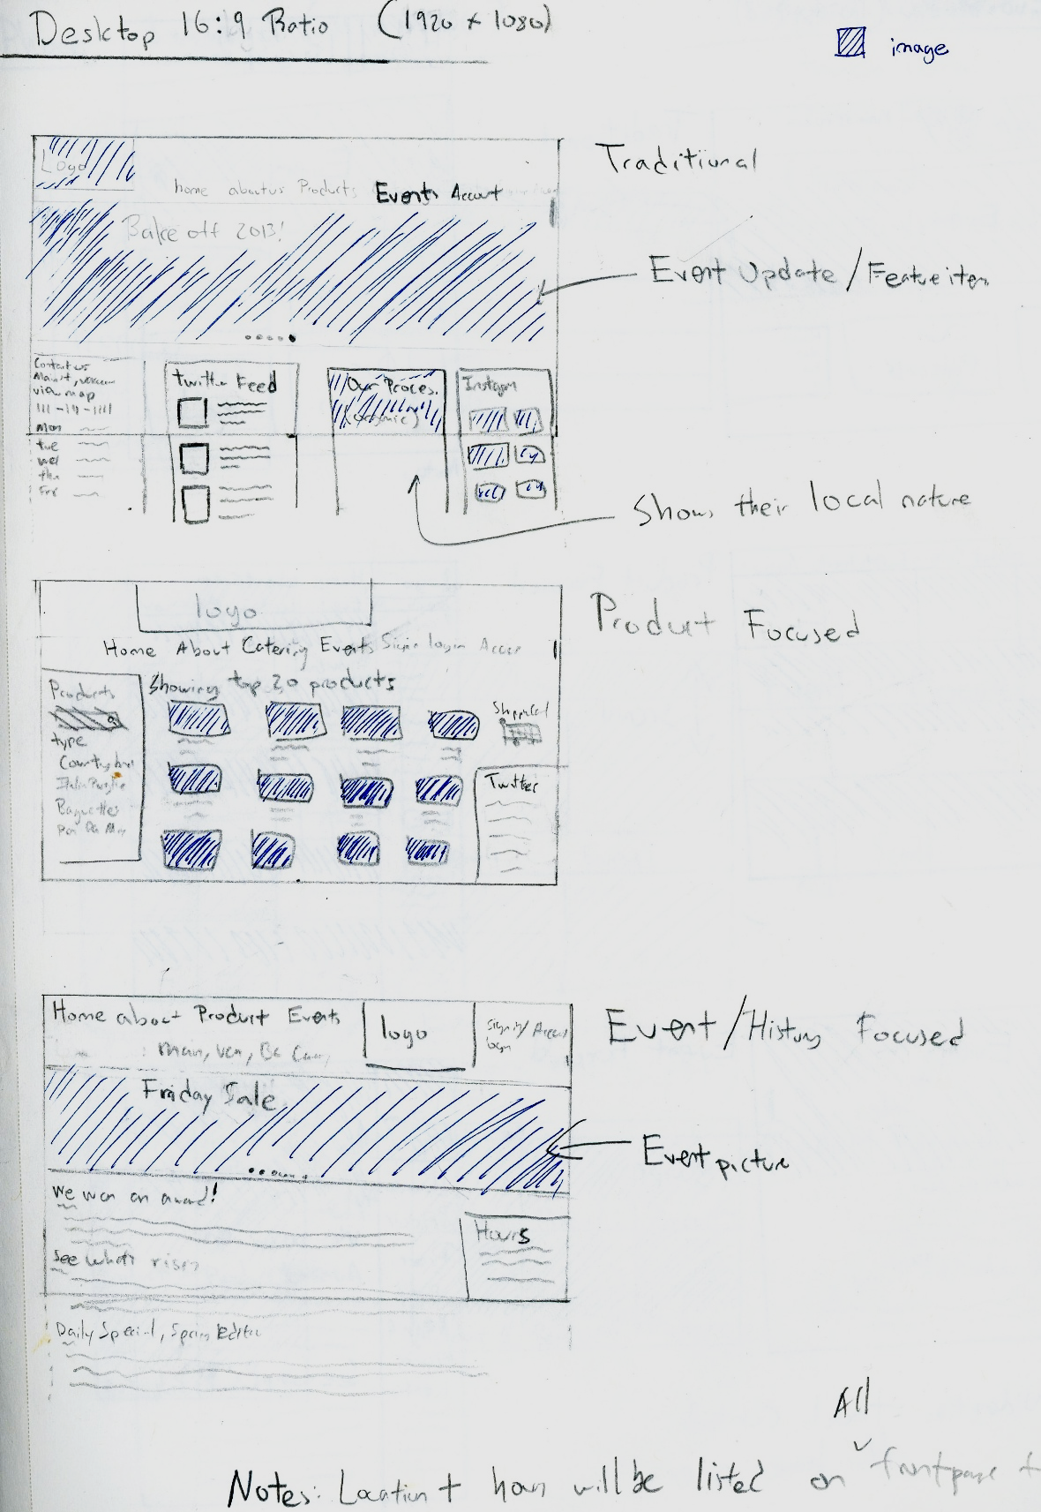

### Tablet SketchesC:\Users\User\Dropbox\SFU\Summer 13\IAT 381\Tablet Sketch.jpg

### C:\Users\User\Dropbox\SFU\Summer 13\IAT 381\Phone Sketch.jpgPhone Sketches

## Step 3: Critique from peers

* “Your website sketches lacked context and looks generic”
* “There is a good sense of hierarchy”
* “Does it make sense to have such a complex site structure given the local nature of the website?”
* “That’s a great way to think about how to create different the layouts. Instead just trying different ways of rearranging the stuff on the website, you provided a theme and rationale for each design.”
* “There’s a lack of color so it was hard to tell different between different elements.”
* “Shouldn’t the desktop version and the tablet version stay relatively the same?”

# Week 2: Wireframes

## Step 1: Revisiting concept sketches

One of the biggest problems our class encountered was that we all went straight to making wireframes. Thus, we were given the task to revisit concept sketches as they should drive the aesthetics of the website. To do this, I plan to first create a brand identity for our client. I plan to use the aesthetics created here to drive the look and feel of their website. Below are some of my initial logo ideas.

### Initial Logo sketches

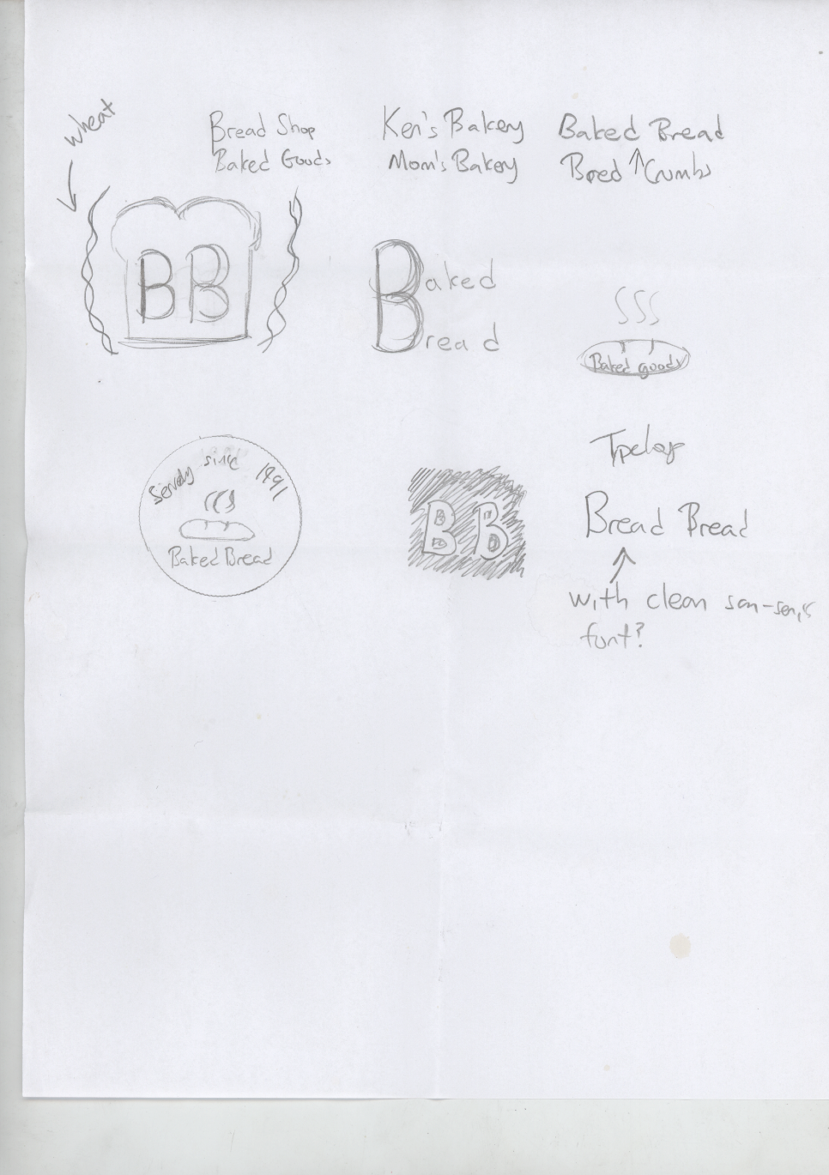

### Digital Logo Recreation

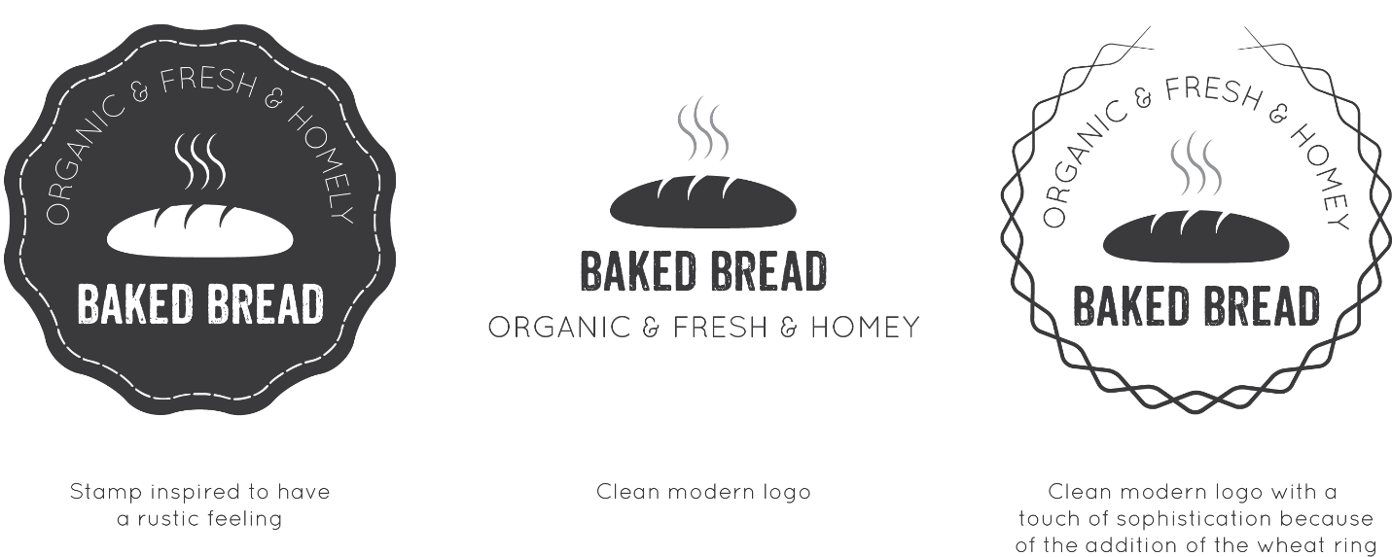

I ended up choosing the logo on the far right because it communicated a higher level of sophistication while providing a modern and chic look.

## Step 2: A List of all content expected to have

Homepage content:

* Slideshow of 3-5 photographs of products & events
* Have general information such as: Phone number, address and business hours
* Generate content for event feed

About page content:

* Information about process
* Owner one information
* Owner two biography

Product Gallery Page:

* Have thumbnails of product pictures
* Have short description underneath the thumbnail about the products
* May include price of product.

Detailed Product page:

* High resolution of the picture
* Short description

Check out page

* Thumbnail of product along with name and quantity

## Step 3: Wireframes

### Set 1 | Homepage |Desktop & Tablet (Landscape)

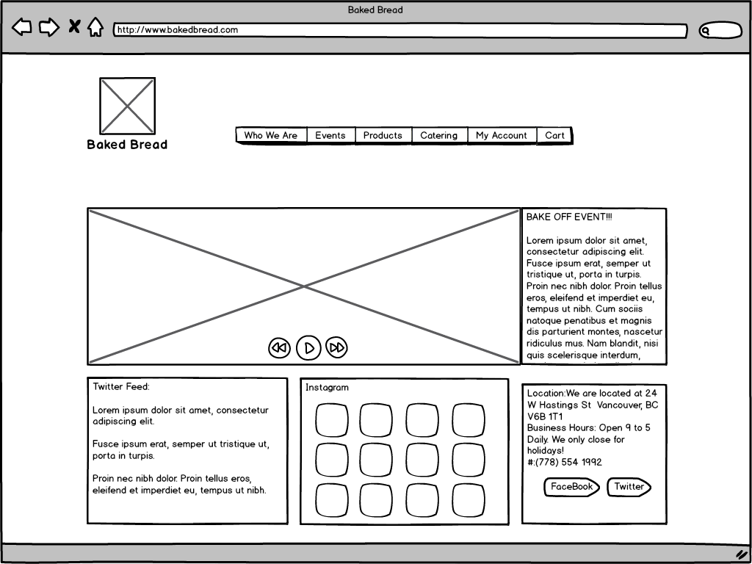

### Set 1 | Homepage | Tablet (Portrait) C:\Users\User\Dropbox\SFU\Summer 13\IAT 381\New Wireframe\Tablet - Portrait.png

### Set 1 | Homepage | Phone (Landscape & Portrait) C:\Users\User\Dropbox\SFU\Summer 13\IAT 381\New Wireframe\Iphone mockup.png

### Set 2 | Who We Are Page | Desktop & Tablet (Landscape) C:\Users\User\Dropbox\SFU\Summer 13\IAT 381\New Wireframe\Desktop mockup2.png

### Set 2 | Who We Are Page | Tablet (Portrait) C:\Users\User\Dropbox\SFU\Summer 13\IAT 381\New Wireframe\Tablet - Portrait2.png

### Set 2 | Who We Are Page | Phone (Portrait & Landscape)

### C:\Users\User\Dropbox\SFU\Summer 13\IAT 381\New Wireframe\Iphone mockup2.png

### Set 3 | Product Page | Desktop & Tablet (Landscape) C:\Users\User\Dropbox\SFU\Summer 13\IAT 381\New Wireframe\Desktop mockup3.png

### Set 3 | Product Page | Tablet (Portrait) C:\Users\User\Dropbox\SFU\Summer 13\IAT 381\New Wireframe\Tablet - Portrait3.png

### Set 3 | Product Page | Phone (Portrait & Landscape) C:\Users\User\Dropbox\SFU\Summer 13\IAT 381\Wireframe\Iphone mockup3.png

## Step 4: Critique from peers

* “Have you thought about how the buttons would work for the desktop versus browser?”
* “For the phone size, the directory listing style looks a bit old school. Maybe you should have buttons instead.”
* “Do you really need an Instagram feed?”
* “Having google maps for location would make it easier for the user to see”
* “It makes more sense to have the Facebook and Twitter icon to be on all pages than just the homepage”

# Week 3: Mockups

## Step 1: Develop detailed and complete elements for the webpages

### Homepage

#### Slideshow image & text:

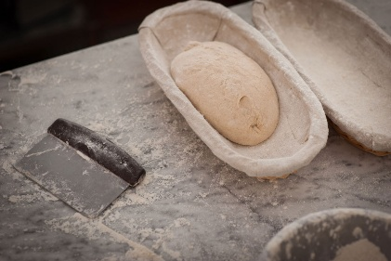

Annual Bake Sale is on May 12!

Hey guys, to celebrate our second year anniversary, we are going to have a huge sale that will only be happen on May 12! Stores will open at the same time as usual. Supplies are limited, please come early if you do not want to be disappointed. All Customers will receive a free loafof our up and coming concept bread.-Ken & Julie

#### Twitter feed:

* We won the international baking award!
* Sourdough Bread is on sale! Check us out
* Julie and I are getting married!

#### Today’s Feature Bread:

Organic rye bread with a touch of cinnamon

#### General information:

* Phone: (778) 554 1992
* Business Hours: Open 9 to 5 Daily. Close on holidays.
* Location: We are located at 24 W Hastings St Vancouver, BC V6B 1T1

### C:\Users\User\Dropbox\SFU\Summer 13\IAT 381\images\wallpaper-1113888.jpgOur Story

#### Local Farms

We only use locally sourced organic wheat. Baked Bread bakes fresh bread daily. No bread or dough is EVER left overnight.

#### C:\Users\User\Dropbox\SFU\Summer 13\IAT 381\images\JGL-joseph-gordon-levitt-33425883-500-600.jpg

#### About Ken

Born and raised in Surrey, Ken had his first bakery job to fund his college degree and it was love at first sight. Upon graduation, Ken entered the Hell’s Kitchen show and was awarded first place and was given a position in Gordon Ramsey’s famous bakery overseas in Paris named *Maze.* He work and learned from the best for three years. Because of their diverging vision of the future of bakery, Ken eventually had a falling out with head chef Au Trianon.

Ken then moved back to Surrey and open *Baked Bread* in the heart of Vancouver in which he focused exclusively on bread. His vision for the bakery simple yet ingenious. He wanted his bread, which is simply a combination of flour, water, and salt to positively impact a person’s mood for the day, week or even a life time.

#### C:\Users\User\Dropbox\SFU\Summer 13\IAT 381\images\Emmy+Rossum+emmy_rossum.jpgAbout Julie

Born and raised in Paris, Julie was an orphan and had her first bakery job since she was fifteen. Discovered by Gorden Ramsey for her innate ability to “listen” to bread, she was taken in and trained by Au Trianon. She spent 10 year of her life working at the restaurant *Maze.* She met Ken connected with his ideals on bread making and hated Au Trianon ideals.

After Ken’s falling out with Au Trianon, she decided to follow Ken to Surrey and helped open *Baked Bread* with Ken. Like Ken, her vision for the bakery simple yet ingenious. She wanted her bread, which is simply a combination of flour, water, and salt to positively impact a person’s mood for the day, week or even a life time.

### Product listing

|  |  |  |
| --- | --- | --- |
| House Bread $12C:\Users\User\Dropbox\SFU\Summer 13\IAT 381\images\joseph-brot.jpg | Lavender Honey Bread $15C:\Users\User\Dropbox\SFU\Summer 13\IAT 381\images\roggen-honig-lavendel-brot.jpg | Root Bread $13 |
| Walnut sourdough loaf $13  C:\Users\User\Dropbox\SFU\Summer 13\IAT 381\images\walnuss-brot.jpg | Spelt Flake bread with grapes $14C:\Users\User\Dropbox\SFU\Summer 13\IAT 381\images\frischflocken-dinkel-brot.jpg | Wild rye bread with apples $12  C:\Users\User\Dropbox\SFU\Summer 13\IAT 381\images\roggen-sommerapfel-brot.jpg |
| Sour hops bread $12  C:\Users\User\Dropbox\SFU\Summer 13\IAT 381\images\kuerbiskern-brot.jpg | Whole wheat bread $10  C:\Users\User\Dropbox\SFU\Summer 13\IAT 381\images\vollkornsaaten-brot.jpg |  |

### Detailed product view

Root Bread $13

The Root kneaded bread with soft wheat and two different sourdough wheat (soft and hard wheat), with no yeast. The absence of yeast requires a large curing time and double cooking time and gives it a special flavor and taste to the crumb and crust and great durability. Characteristic of bread is the wild, with characteristic aromas crust and crumb filled blisters due to its long maturation of dough.

## Step 2: Mockups

### Set 1 | Homepage |Desktop & Tablet (Landscape)C:\Users\User\Dropbox\SFU\Summer 13\IAT 381\Mockups\Set 1\Desktop - Homepage-01.png

### Set 1 | Homepage |Desktop Interactive ElementC:\Users\User\Dropbox\SFU\Summer 13\IAT 381\Mockups\Set 1\Desktop - Homepagehover-01.pngs

### Set 1 | Homepage | Tablet (Portrait)C:\Users\User\Dropbox\SFU\Summer 13\IAT 381\Mockups\Set 1\Desktop - Homepage-02.png

### Set 1 | Homepage | Phone (Portrait & Landscape)

### C:\Users\User\Dropbox\SFU\Summer 13\IAT 381\Mockups\Set 1\Desktop - Homepage-03.png

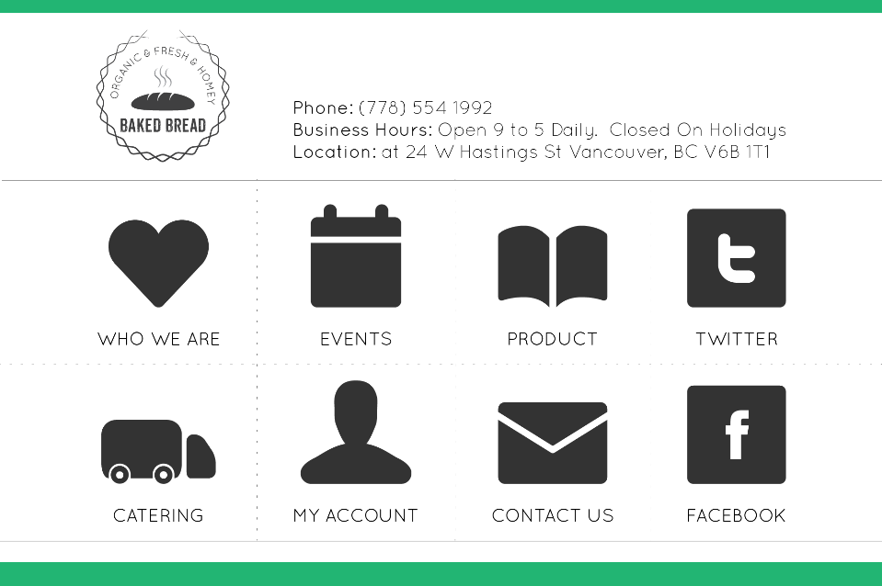

### Set 2 | Homepage |Desktop & Tablet (Landscape)

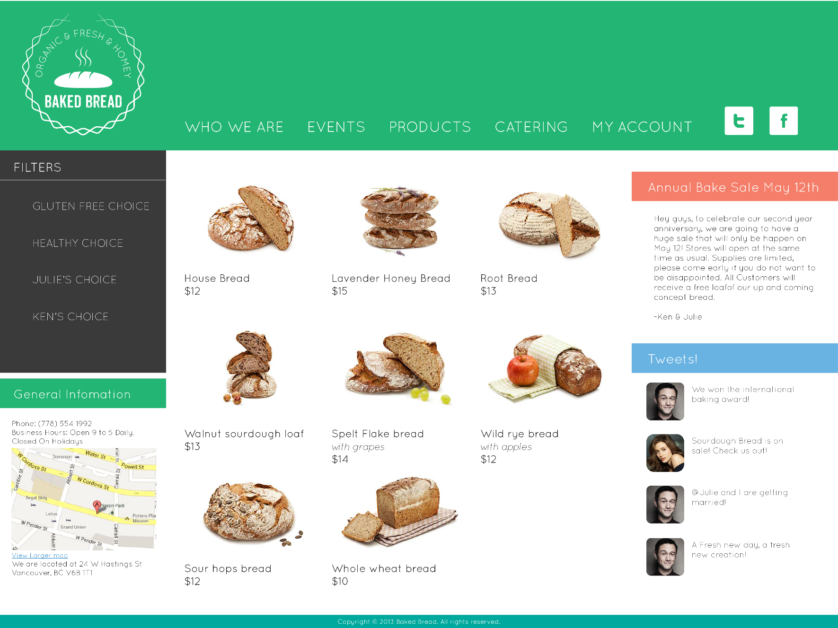

### Set 2 | Homepage |Desktop Interactive ElementsC:\Users\User\Dropbox\SFU\Summer 13\IAT 381\Mockups\set 2\Desktop - Homepage set2-05.png

### Set 2 | Homepage | Tablet (Portrait)

### C:\Users\User\Dropbox\SFU\Summer 13\IAT 381\Mockups\set 2\Desktop - Homepage set2-02.png

### Set 2 | Homepage | Phone (Portrait & Landscape)

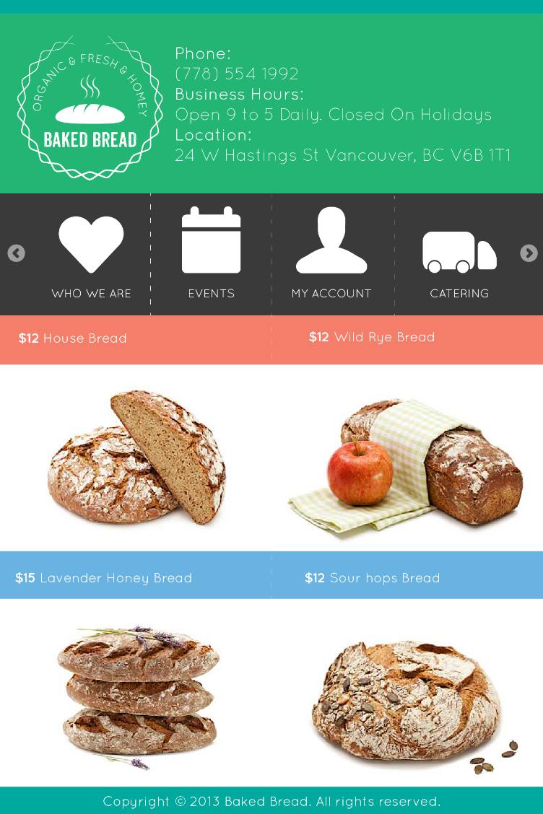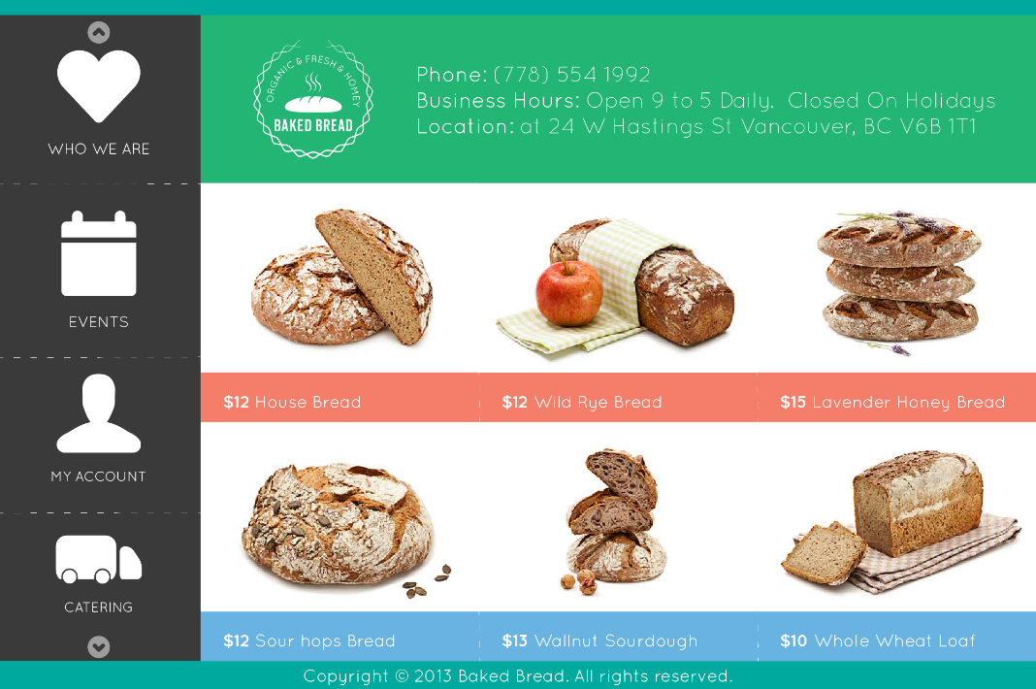

## Step 3: Concept choice:

I think the client should choose the first set because the aesthetics and content choice ties in better with the value of the company. In the second one, the colorful elements makes an upbeat and playful site but does not provide the elegant look that is needed. In the first set, the white background and minimal look makes the website give off a modern and upscale feeling that embodies the values of the company. Another problem with set two is that the large variety of colors and content make it a bit hard to read. Next, the first set feels more like a community focused website. Whereas, with the second design, the company feel more like one that only wants to sell products. This layout would have work fine for other companies such as book companies which focuses on showcasing many different types of books. But for a small local bread company, they should focus more on engaging the community.